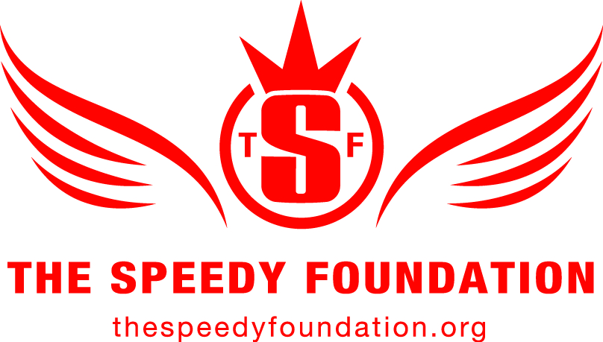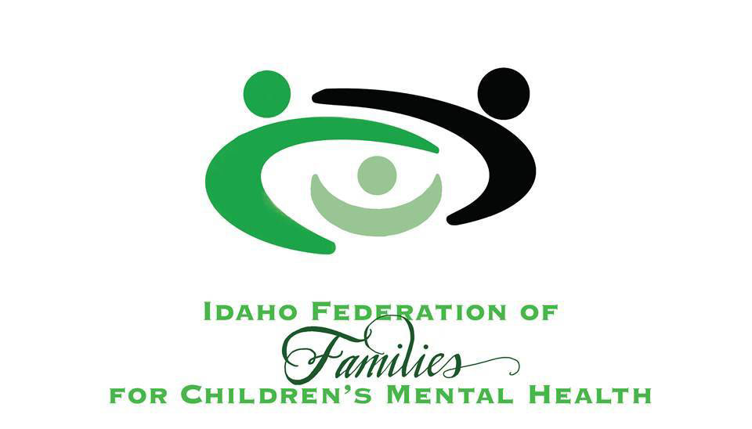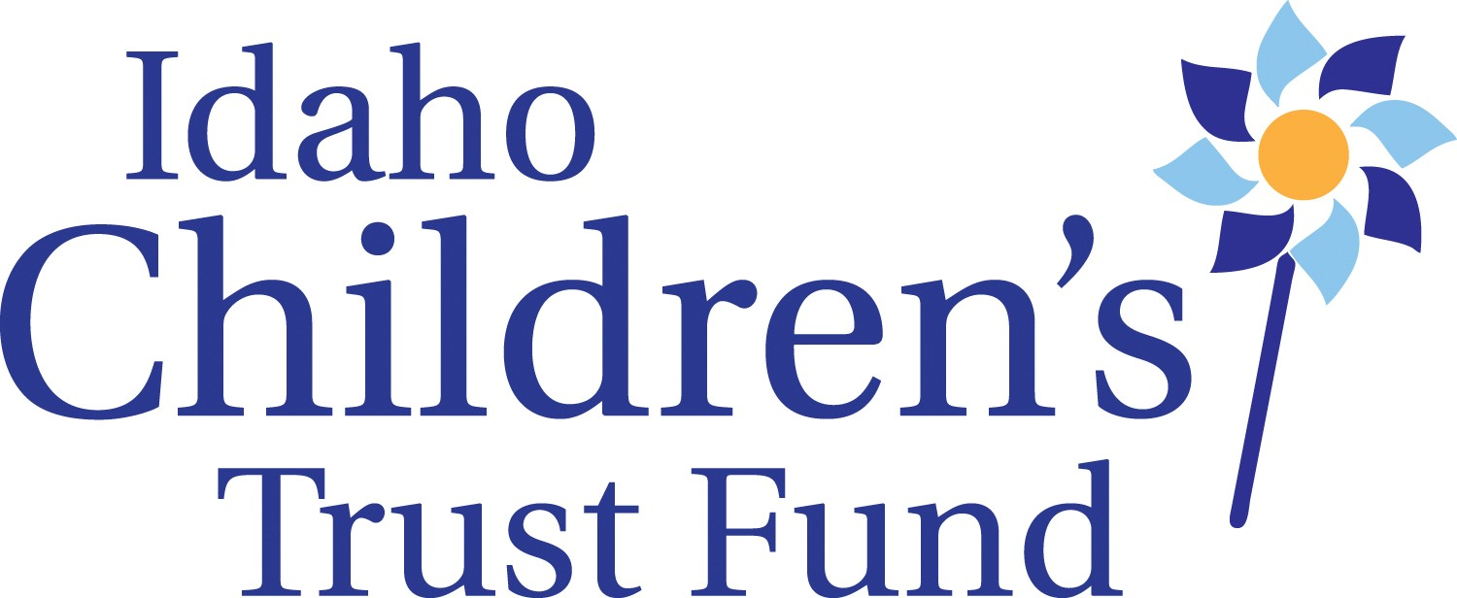

N E W S R E L E A S E

Contacts: Jann Marie Stockwell
Optum Idaho
(208) 914-2289
jann.stockwell@optum.com

Free Screening Coming to Caldwell of James Redford Documentary Examining Long-Term Impact of Childhood Trauma, and Opportunities for More Effective Prevention

Film examines long-term effects of childhood trauma and science behind cutting-edge therapies designed to protect children from harm caused by toxic stress

CALDWELL, Idaho (APRIL X, 2017) – A free public screening of the award-winning documentary, RESILIENCE: The Biology of Stress and the Science of Hope, is coming to the Treasure Valley through a partnership between Optum Idaho, the Idaho Children’s Trust Fund, The Speedy Foundation and the Idaho Federation of Families. The screening, and an accompanying panel discussion featuring local community health experts, will be Thursday, April 6 at 6:30 p.m. MDT at Vallivue High School in Caldwell. Admission is free.

RESILIENCE is a James Redford film that focuses on the fact that a child may not remember what happened in their early life, but their brain never forgets. It shows how researchers are exploring a biological syndrome caused by abuse and neglect during childhood – called Adverse Childhood Experiences (ACEs). The film demonstrates how the stress of these early experiences can trigger hormones that affect children’s’ brains and bodies, putting them at a greater risk for disease, homelessness, prison time and early death.

“We’re excited to bring this documentary to Idaho and share new ways to help children affected by trauma grow into successful individuals,” said Georganne Benjamin, executive director of Optum Idaho. “This can be a difficult topic for communities to discuss. RESILIENCE allows us to take an educated look at this issue and come up with a proactive approach to addressing the problem."

“Childhood trauma expert Dr. Robert Anda said ‘what’s predictable is preventable’. With that in mind, we want to educate the entire community, especially professionals, who work with children and families on the effect these experiences have on children’s brains and bodies,” said Roger Sherman, executive director of the Idaho Children’s Trust Fund. “With this knowledge, we can work together to strengthen communities and families to both prevent childhood trauma from happening in the first place, and bolster the children who already have ACES to ultimately improve their life outcomes.”

"To be a truly trauma-informed community we must have patience with others and ourselves as we seek to acquire the skills and attitudes of a trauma-informed practice," said Shannon Decker, executive director of The Speedy Foundation. “The screening of RESILIENCE is an opportunity to approach this topic as a community and have an honest conversation.”

RESILIENCE will be screened around the state as a follow-up to screenings of Paper Tigers that took place in the fall of 2016, also through the partnership between Optum Idaho, the Idaho Children’s Trust Fund, The Speedy Foundation and the Idaho Federation of Families.

“I believe that the film Paper Tigers was wake-up call to parents, educators, kids and all who work with youth regarding childhood trauma and its dramatic impact on our lives and community,” said Stephen Graci, executive director of Idaho Federation of Families. “This follow up event, RESILIENCE, takes it a step beyond; it is the call to action and should be added to everyone’s must see list.”

Additional screenings of the film will take place in Twin Falls on May 11, Boise on May 13, Fort Hall on May 17 and Lewiston on May 22. For more information, and to get your free ticket to an upcoming screening, please visit www.thespeedyfoundation.org/resilience.

About Optum Idaho
Optum Idaho serves Idaho Medicaid members who need access to outpatient behavioral health services. Optum is responsible for ensuring that appropriate and adequate behavioral health services that support the practices of recovery and resiliency are available. More information is available at www.optumidaho.com.

About Idaho Children’s Trust Fund
The Idaho Children's Trust Fund is the state affiliate of Prevent Child Abuse America. The organization provides funding, training and technical assistance to community-based programs working to strengthen families in order to prevent child abuse and neglect in Idaho. More information is available at www.idahochildrenstrustfund.org.

About The Speedy Foundation
The Speedy Foundation is a non-profit organization dedicated to preventing suicide, supporting mental health and promoting conversations to end the stigma surrounding both. It was formed in 2011 in the loving memory of Jeret “Speedy” Peterson, an Olympic freestyle aerials medalist whose life was characterized by his service to others. Speedy ended his life in July 2011 at age 29. For more information, please visit www.thespeedyfoundation.org.

About Idaho Federation of Families for Children’s Mental Health
The Idaho Federation of Families for Children’s Mental Health is a statewide Parent and Youth directed non-profit organization. IFFCMH serves as the ID Statewide Family Network and ID affiliate of Youth MOVE National. IFFCMH offers assistance to youth and parents seeking or receiving mental health services. Programs include youth support and education groups statewide, an on-going series of streamed educational webinars, statewide Youth MOVE program, and Family Support Partner certification training program. Find us at www.idahofederation.org and on Face Book.

###

